Retro Racket Revolution



Game Design Document

Contents

# Vision

# Main Design Elements

UI

* Player 1 score
* Player 2 score
* High score
* High score table

## Play Area

* 15 wide (columns)
* 12 deep (rows)
* (Column, Row)

# Feature References

## Batty, ZX Spectrum, 1987

### Collectibles

* Slow ball
* Increase bat size
* Decrease bat size
* Multiball
* Powerball
* Catch

### Obstacles

* Aliens dropping bombs
* Disrupters

# Level References

## Batty, ZX Spectrum, 1987

Level 1

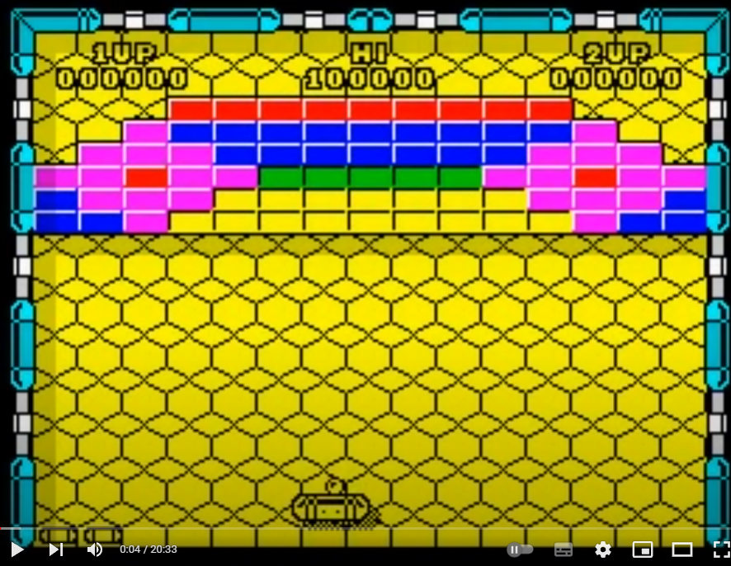

Level 2

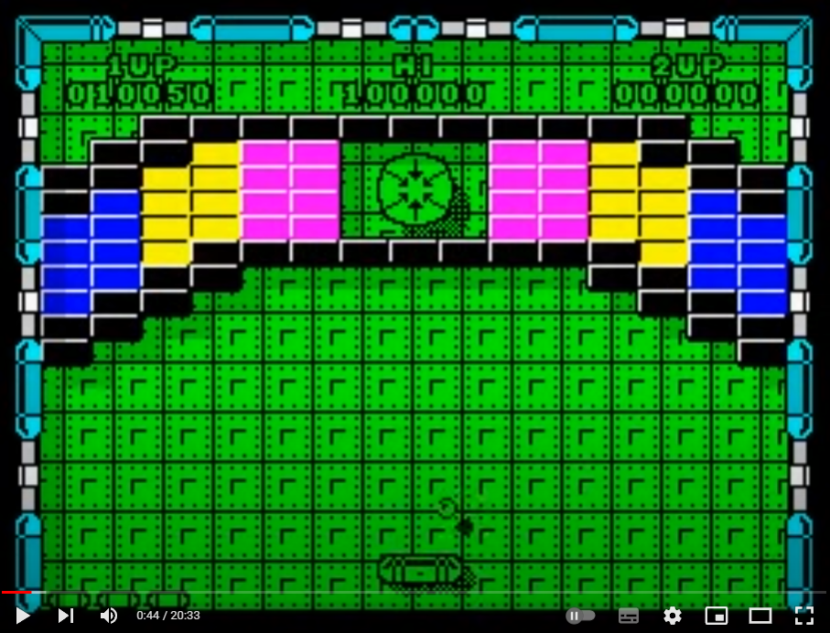

Level 3

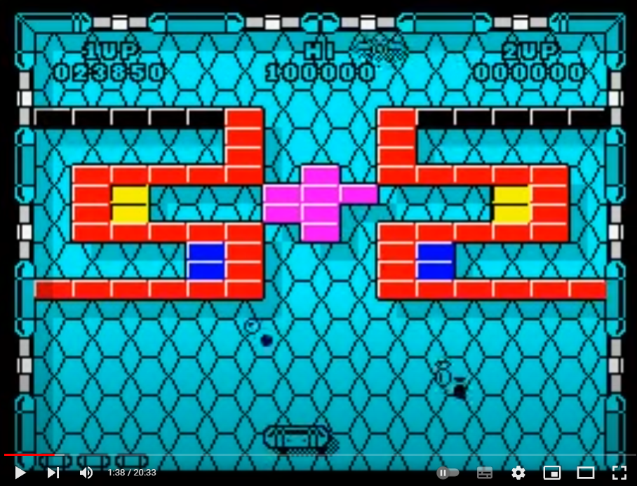

Level 4

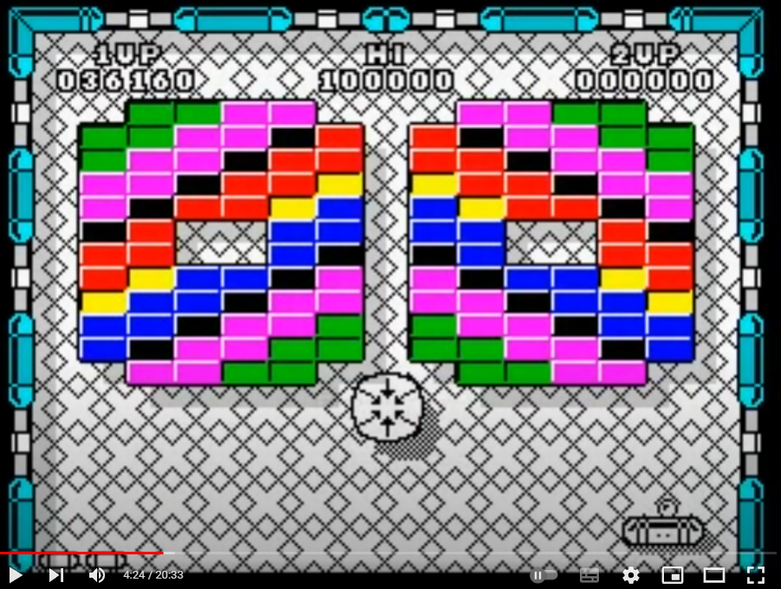

Level 5

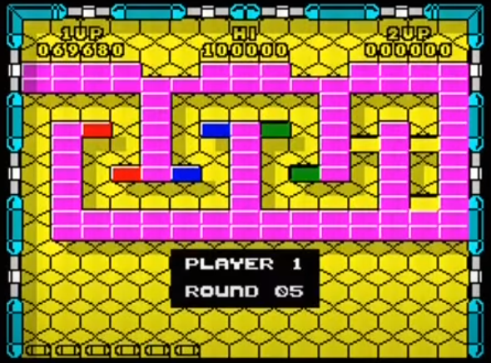

Level 6

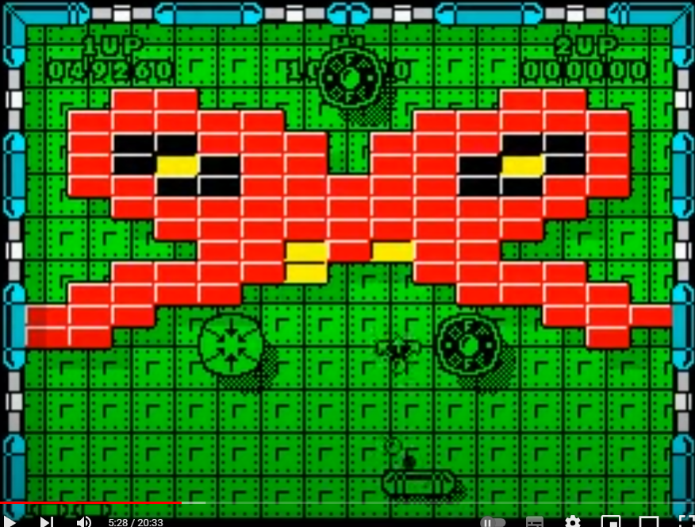

Level 7

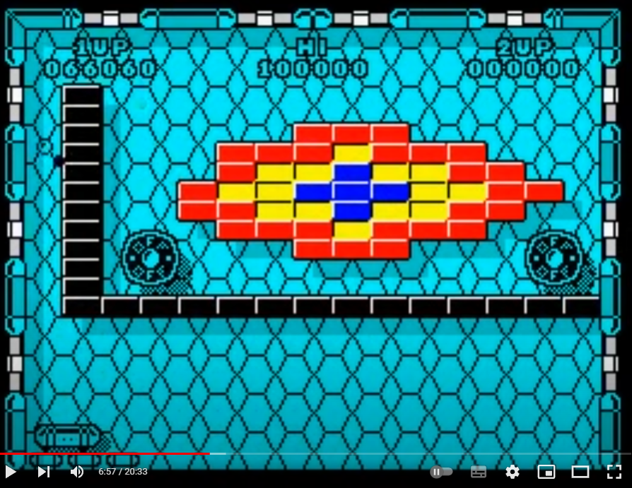

Level8

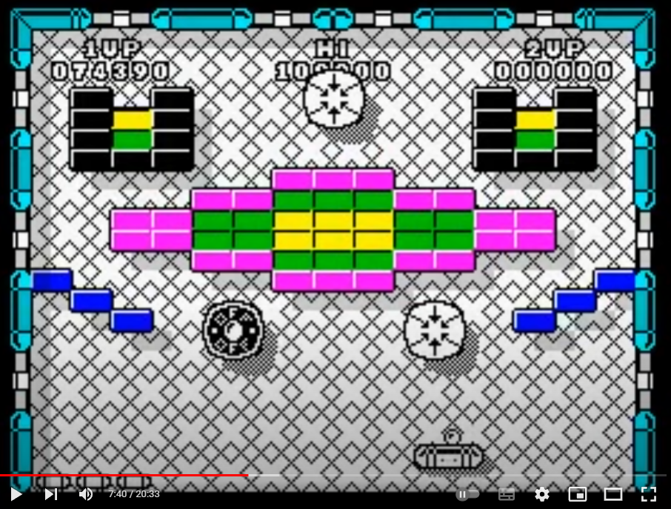

Level 9

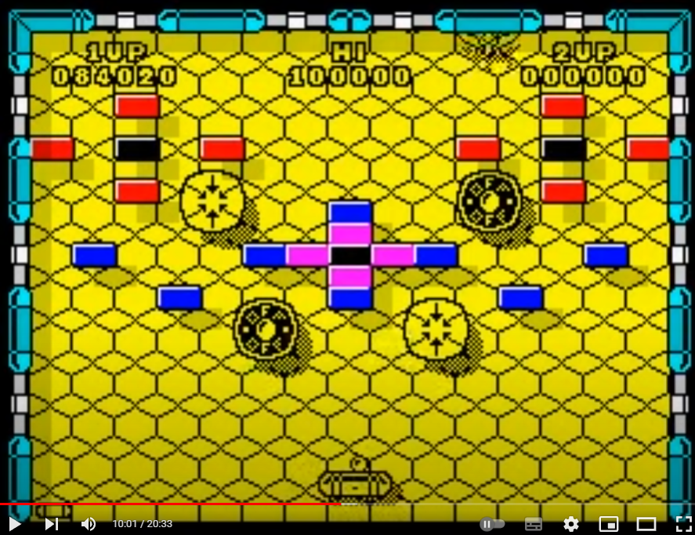

Level10

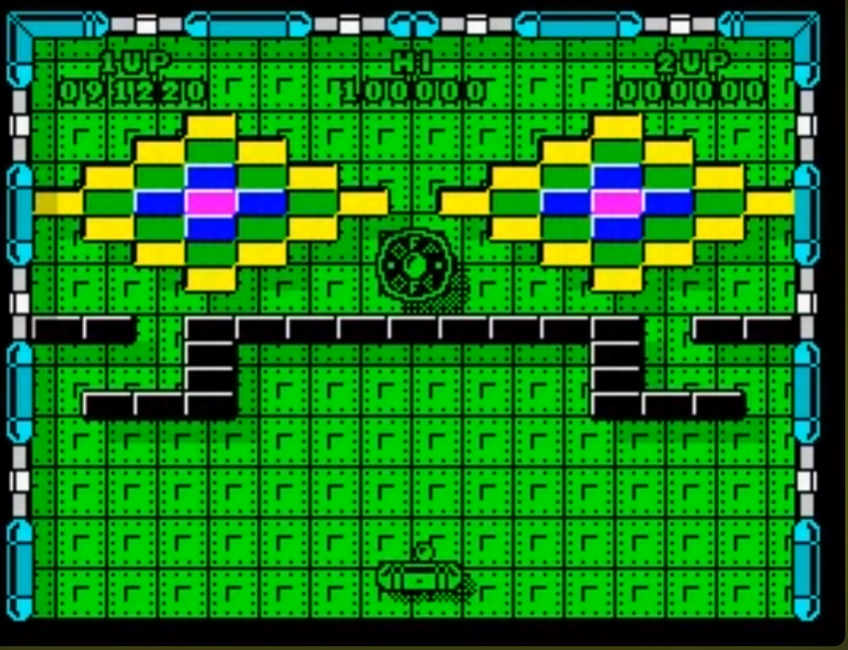

Level11

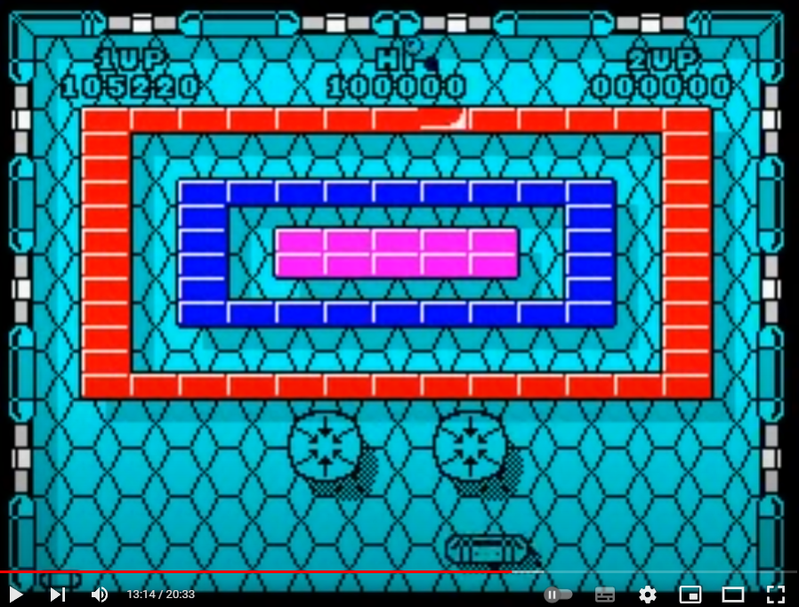

Level12

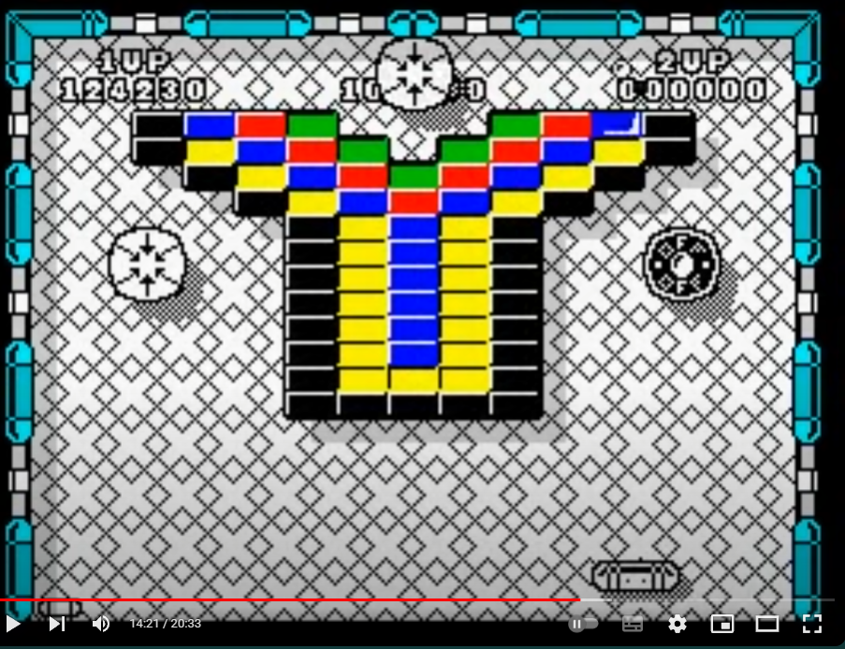

Level13

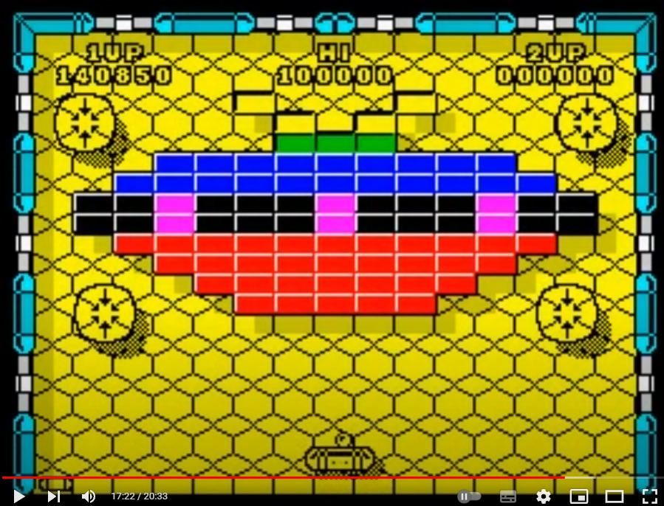

Level14

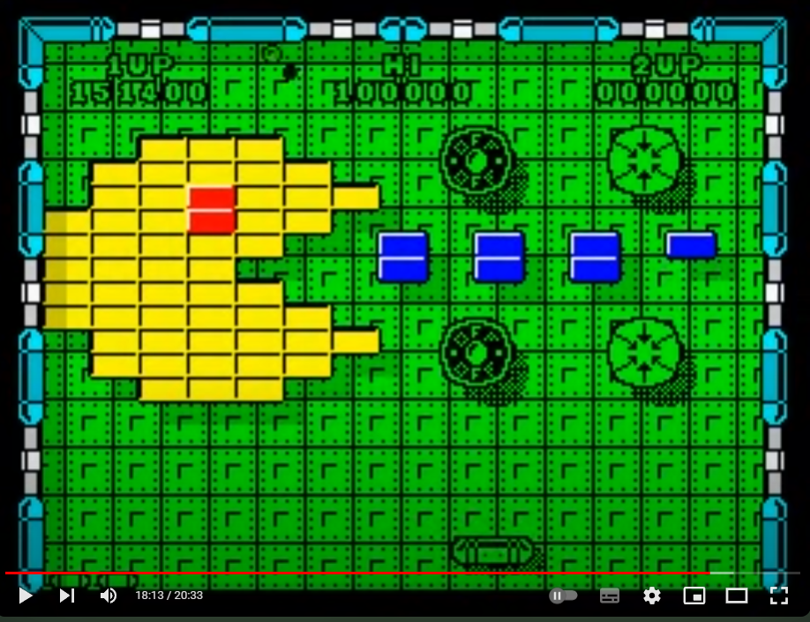

Level15

